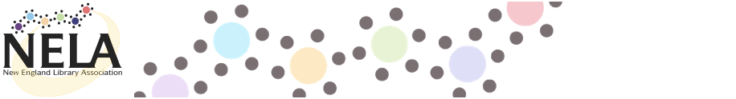

MAIL-IN REGISTRATION FORM

**New England Technical Services Librarians (NETSL) Annual Conference**

Friday, April 8, 2016

9:30 a.m. - 3:30 p.m. (Registration begins at 8:30 a.m.) Hogan Campus Center, College of the Holy Cross, Worcester, Mass.

**Please print this form and mail it with your check by Friday, March 25, 2016 to:** Alana Verminski

Alana Verminski

Collection Development Librarian

University of Vermont Libraries

538 Main Street

Burlington, VT  05405

802-656-8350

alana.verminski@uvm.edu

NELA refund policy: Refunds are granted with 10 business days’ notice. Substitutions welcome.

**No walk-in registrations.**

*Questions? Contact Alana Verminski,* [alana.verminski@uvm.edu](mailto:alana.verminski@uvm.edu),802-656-8350

Directions to the College of the Holy Cross are available at: <http://www.holycross.edu/directions/hogan.html>

*If you have a dietary restriction, please contact Mary Moran at [mjmoran@holycross.edu](mailto:mjmoran@holycross.edu)

(No need to email for vegetarian and vegan options. They will be provided.)

Name: ________________________________________________________________

Institution: _______________________________________________________________

City: ______________________________ State: __________________________

Email: ____________________________ Phone: ____________________________

**Cost** (Make check payable to **NELA**; NELA tax exempt number: 04-2326479):

|  |  |  |  |  |
| --- | --- | --- | --- | --- |
|  |  |  | $55 | NETSL/NELA Personal Member |
|  | | | $85 | Non-Members |
|  |  |  |
|  |  |  | $25 | Currently Unemployed / Library School Student |

**Breakout Session 1 Preference**

|  |  |  |  |  |
| --- | --- | --- | --- | --- |
|  | | | 1A | Shared Print Monographs: Analysis and Action / Rick Lugg, Executive Director, OCLC Sustainable Collection Services, and Ruth Fischer, Senior Product Manager for GreenGlass, OCLC Sustainable Collection Services |
|  |  |  | 1B | [Session on implementing an open source ERM, title TBA] / Erin Wentz, Electronic Resources Librarian, Massachusetts College of Pharmacy and Health Science, Wheelock College, and Louisa Choy, Digital Services Librarian, Wheelock College |
|  |
|  |  |  | 1C | Everything you ever wanted to know about System Librarianship (but were afraid to ask) / Emily Singley, Head Librarian, Systems & Applications, Boston College, and Alison Thornton, Technical Services Systems Support Librarian, Harvard University |
|  |
|  |  |  | 1D | State of Technical Services in the Public Libraries / Judy Njoroge, System Librarian for Bibliographic Services, Library Connection, Inc. |
|  |

**Breakout Session 2 Preference**

|  |  |  |  |  |
| --- | --- | --- | --- | --- |
|  | | | 2A | **What Now? Current Opportunities in Preparation for Linked Data in Libraries** / Steven Folsom, Metadata Technologies Program Manager |
|  |  |  | 2B | Collaborative Development of the Perseus Catalog / Alison Babeu, Digital Librarian, Perseus Digital Library |
|  |
|  |  |  | 2C | Building a Shared Print Network in New England and Beyond / Matthew Revitt, Special Collections and Maine Shared Collection Librarian & Anna Perricci, Project Manager, Eastern Academic Scholars’ Trust (EAST) |
|  |
|  |  |  | 2D | [Session on linked data training, title TBA] / Rob Chavez, Library Juice Academy |
|  |