FAST (Faceted Application of Subject Terminology)
Project Update
ALCTS CCS SAC FAST Subcommittee
ALA Annual, Washington, D.C., 2010

The initial development of FAST was completed in 2009 and the focus has shifted to documentation, maintenance and enhancement. The documentation effort produced FAST: Faceted Application of Subject Terminology: Principles and Application. The book is being published by Libraries Unlimited and is expected to be released in July. The book’s 354 pages includes four parts; (1) Introduction, (2) FAST Headings, (3) Application of FAST, and (4) Authority Control and Implementation. It will also be available as an eBook. The lack of detailed documentation has been an impediment to the early FAST implementers.

.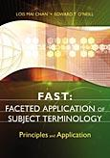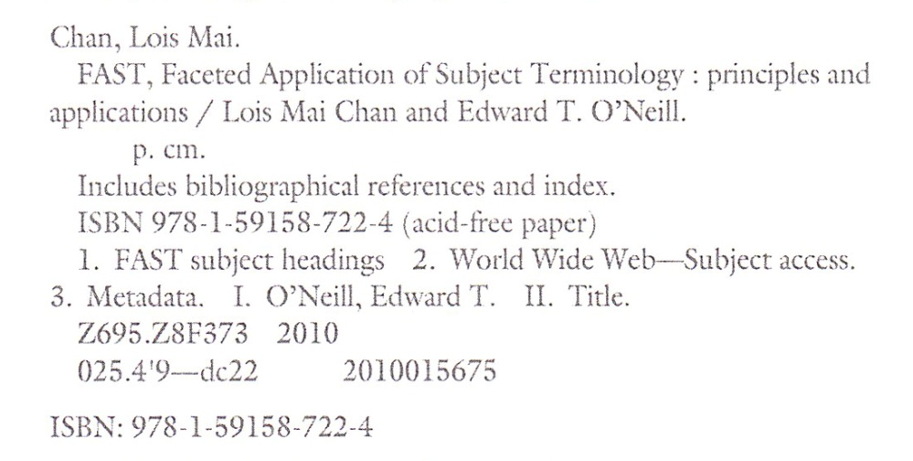

The other major developments in the past year included:

- Adding of additional references,
- Improving the conversion of LCSH to FAST,
- Addition of geographic coordinates and feature types.
- Adding the ability to accept user contributions (particularly Geographic information)

The total number of FAST authority records has changed only slightly. As of the end of June 2010, The FAST authority file contained:

Facet | No. of Authorities
Personal names | 698,708
Corporate names | 351,000
Events | 10,578
Titles | 48,134
Periods | 676
Topicals | 384,090
Geographics | 148,640
Form/Genre | 1,751
Totals | 1,643,577

Some new headings were added and a few duplicate and erronious headings were deleted but most of the activity focused on adding (1) geographic information, (2) references, and (3) links to LCSH authorities. While is still a brief time lag between FAST and LCSH, the lag has been reduced.

The FAST database is available at http://fast.oclc.org. The full FAST authority file can be licensed for non-commercial use.

The current research efforts are focused on (1) enriching the FAST authority records with addition information (2) supporting a variety of applications, both within OCLC and outside, that are using FAST (2) demonstrating the advantages that FAST offers as a fully enumerative faceted subject heading schema.

OCLC Research has successfully used FAST in several projects including FictionFinder, Terminology Services, and WorldCat Identities. Online demos on these projects are available at http://www.oclc.org/research/activities/researchworks.htm. FAST has been particularly advantageous in applications employing tag clouds. Another FAST prototype combines FAST with Google Maps creating a GUI to search for geographic resources. This prototype, currently limited to the state of Michigan, is available at http://fast.oclc.org/FASTMap/index.html.

The FAST team continues to explore collaborative effects to improve FAST. We are very interested in working with the community to further enhance FAST and are exploring ways to allow the community to add and/or correct information in FAST records. As a start, we are encouraging users to add geographic coordinates and feature type to FAST authorities. The FAST database now includes a link in geographic authorities display to allow user input of the coordinates. We are considering additional options for augmenting and/or correcting FAST authorities.
Please address any questions or comments to Ed O’Neill at oneill@oclc.org.

June 18, 2010

