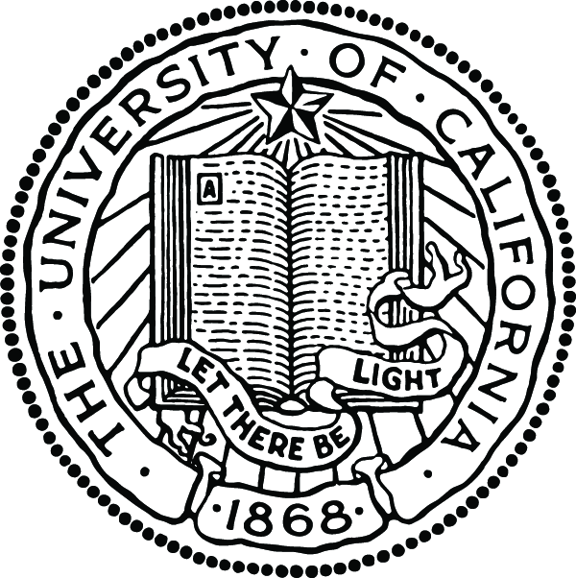

THE UNIVERSITY LIBRARIES
UNIVERSITY OF CALIFORNIA, RIVERSIDE

Assistant/Associate University Librarian for Collections and Scholarly Communications

The University of California, Riverside Libraries is seeking nominations and applications for an innovative, flexible, and knowledgeable administrator to fill the position of Assistant/Associate University Librarian for Collections and Scholarly Communications.

Reporting to the University Librarian, the AUL for Collections and Scholarly Communications will be a member of the senior administrative team. The successful candidate will join a team of four AUL positions (AUL for Administration, AUL for Research and Instructional Services, and AUL for Information Technology and Systems) that will assume responsibility for collaborative leadership, management, and decision making in their respective areas of responsibility on a library-wide basis. The team will share with the University Librarian strategic responsibility for advancing library programs and services in support of the university’s research, education, and public service mission. The successful candidate for the position will have an unusual opportunity to actively participate in shaping the quality and character of the campus and the excellence of the Libraries in a systematically evolving and dynamic environment.

Responsibilities: Major responsibilities of the Assistant/Associate University Librarian for Collections and Scholarly Communications include collection development policy, acquisitions, cataloging and metadata, serials, government documents, and electronic resources planning and coordination. The successful candidate will be responsible for the successful planning, organization, policy development, implementation and direction of all aspects of these areas. The incumbent is a member of the Libraries’ executive leadership group and represents the University Librarian as appropriate. Overall responsibilities include developing strategic directions with department and division heads for acquisitions, serials, collections, cataloging, government documents, and electronic resources; fostering effective working relationships with library and academic colleagues, enhancing and assessing service quality, and playing a leading role in library-wide planning initiatives. Specific responsibilities include leading a team of area/department heads in collection development and technical services in redesigning work processes and services in support of learning, teaching and research; managing and directing the Libraries’ collections budget of $5.4 million; providing leadership and training to academic liaisons who serve as collection managers working closely with the Assistant University Librarian for Research and Instructional Services; initiating library-wide discussion on collection management and development as well as scholarly communications; working with the University Librarian in planning and communicating to the academic community the Libraries’ scholarly communications program; and representing the University Libraries in the UC system-wide planning for scholarly communications initiatives, and in local, regional, and national arenas as appropriate.

Minimum Qualifications: MLIS or equivalent from an ALA accredited program is
required with a minimum of five years experience in administering a major unit within a
research library system. Demonstrated experience with or knowledge of collections and technical services at the program level. The successful candidate should have evidence of a strong commitment to collections and technical services; substantial library experience in progressively more responsible positions; demonstrated knowledge of scholarly communications, collections, and technical services issues and trends; demonstrated leadership to effect change in a challenging and complex information environment, with vision, creativity and innovation; management style that is inclusive and empowers others to excel; effective supervisory and team building experience; demonstrated initiatives in program development; demonstrated ability to work well with a diverse employee and user community; demonstrated successful experience in working in a collaborative and collegial research library environment; strong analytical and decision-making skills; demonstrated knowledge of the application of information technology; experience with major automated systems; superior interpersonal skills; and experience in effective planning and budgeting for collections in a complex library environment. Preferred Qualifications: Experience with consortial planning for collection development and in cultivating donor relationships.

Salary and Benefits: Salary commensurate with qualifications and experience within a range
of $75,000-$120,000. Appointment at Assistant or Associate University Librarian rank depending upon qualifications and experience or within the MSP Series. Excellent retirement system, health, and vacation benefits. Within close driving distance to Los Angeles (60 miles) and beach areas.

About the UCR Libraries

The UCR Libraries is comprised of five facilities providing access to more than 2,000,000 volumes, 28,000 print and electronic serials, and 1,700,000 microformats. The Libraries provides services to more than 17,000 students and 1,664 faculty in an institutional environment planning for and experiencing extensive growth in its research, professional school, and graduate student body within the next ten years. The successful candidate will join an enthusiastic staff of 163 FTE librarians and support personnel in continuing to build a research library of excellence within an expanding and diverse university ranked among the top 50 research universities in the nation. The UCR Libraries uses the Innovative integrated library system. Library membership includes ARL,Western OCLC, and the Center for Research Libraries.

Application Information: Submit resume, names and contact information of at least three references, and a signed letter of interest addressing qualifications and experience related to the primary duties of the position to: David Rios, Director of Library Personnel, University of California Riverside, University Libraries, P.O. Box 5900, Riverside, CA 92517, or fax to (951) 827-2255 or email to david.rios@ucr.edu. The search will remain open until the position is filled; for best consideration, application should be received by August 25, 2006.

About the University of California, Riverside

The University of California Riverside (UCR) is one of ten campuses of the University of California System generally recognized as the preeminent public university system in the world. The 1200-acre, park-like Riverside campus is located 60 miles east of Los Angeles and 50 miles west of Palm Springs. The University of California, Riverside, strongly committed to diversity, is experiencing rapid growth in graduate programs, research, and professional schools. UCR is a Carnegie RU/VH institution (Carnegie Research Universities - very high research activity) and land-grant university with many specialized research centers and institutes such as UC Mexus, Center for Ideas and Society, and Center for Nanoscale Science and Engineering contribute to a dynamic environment. The City of Riverside (pop. 260,000) and the surrounding communities of Southern California (pop 3.4 million), including Los Angeles, Temecula, Palm Springs, etc., offer a variety of cultural, intellectual, and recreational activities. Riverside enjoys a moderate cost of living and offers one of the best housing values in California.

The University of California is an affirmative action/equal opportunity employer.

