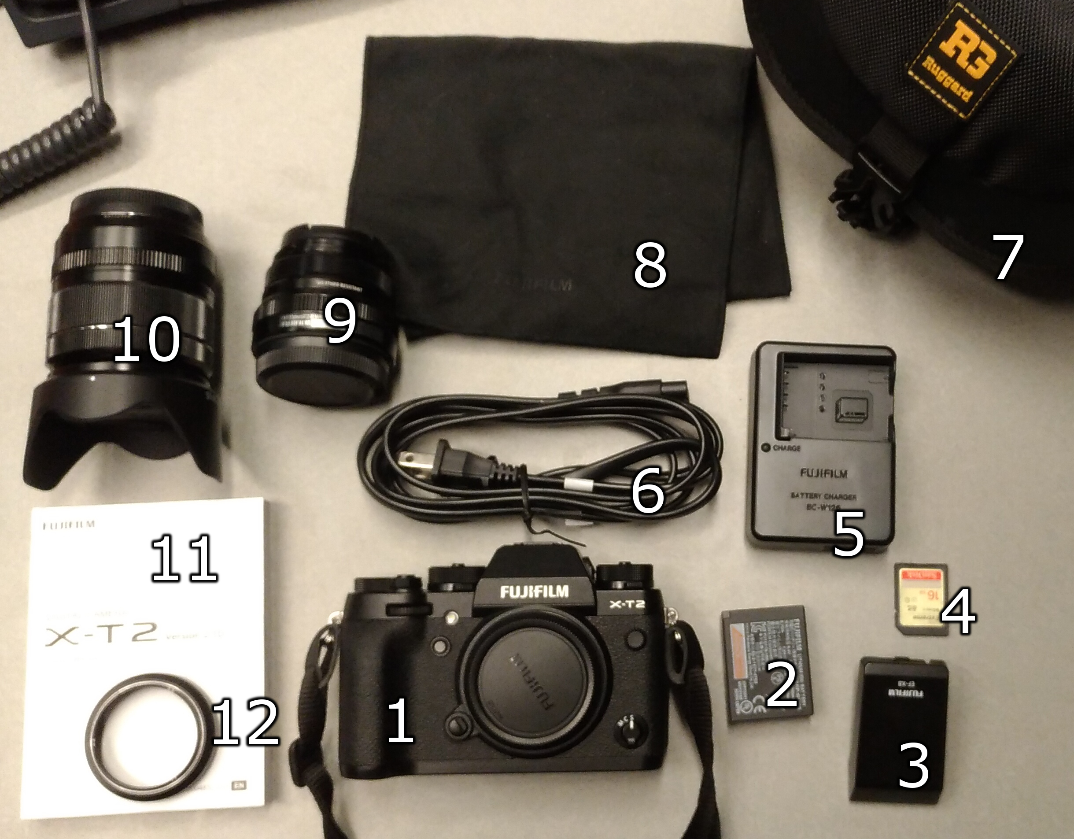

1. Fujifilm X-T2 Digital Camera with strap and body cap
2. Battery
3. Flash
4. SD card
5. Battery Charger
6. Charger power cable
7. Carry case
8. Cloth lens bag
9. 35mm lens with two caps
10. 18-55mm lens with two caps
11. Manual
12. Lens ring

Insert battery into bottom of camera if it is not in already, flip toggle switch to “on” located on the top of the camera. You should be able to press the shutter button and a picture will be stored to the camera. If this does not happen, there is a dial on the top face of the camera, on the left side. The lower selector may need to be moved to “S” in order to take photos. To confirm storage of the picture simply press the small button on the back face of the camera with a picture of a rectangle containing a triangle.

* Make sure all items shown in the photo are accounted for.
* Inspect both the 35mm (#9) and 18-55mm (#10) lenses for physical damage and scratches to the lens.
* Confirm the provided SD card is a 16GB SanDisk.
* Power on the camera and attach lens #9. Make sure the dial is set to ‘P’ and take a few photos. Review the photos by clicking and looking at them to make sure they look correct. Repeat process with lens #10.



* Clear any photos and videos still saved on the SD by clicking and then . When the erase menu appears select “all frames”.

