CORAL: Resource Cost History and Reports Spec

**Overview**

Fenway Libraries Online (FLO) is seeking to modify CORAL to enable the ability to record and report Resource and Organization cost histories.

The goal of the Resource Cost History and Reporting Enhancement is to modify the Resources module to allow for the recording of subscription and cost information over subsequent renewals. The enhancement includes the addition of a year and note field to the Acquisitions tab and database tables. The Expanded Cost History enhancement option adds expanded cost history functionality that includes several additional cost-related fields.

The enhancement specification also includes the extension and renaming of the current Usage Report module to include Cost History Reporting

**Resource Module**

**Configuration Modifications**

Add line to resource/admin/configuration.ini that allows for the optional “Enhanced Cost History”  
Add line to resource/admin/configuration.ini that allows for the optional “Statistics and Reporting” module

**Database Modifications**

“Resource” table modifications

* “subscriptionStartDate” to “currentStartDate”
* “subscriptionEndDate” to “currentEndDate” -
  + Reflects the current subscription and is still used to generate expiration reminders - related code will need to be updated
  + The Calendar function uses this date to determine what dates to display - - related code will need to be updated

Modify the ResourcePaymentTable so that it includes all the following fields (new fields in red):

* resourcePaymentID
* resourceID
* selectorLoginID
* year VARCHAR (20)
* subscriptionStartDate - MMDDYYYY
* subscriptionEndDate - MMDDYYYY
* fundName
* currencyCode
* paymentAmount
* orderTypeID
* costDetailsID
* costNote - Free text field
* invoiceNum - VARCHAR (20)

Create new table CostDetails (Text field set in Admin - Cost Details provides a controlled entry list for use at the institutions discretion

* costDetailsID INT(11)
* shortName VARCHAR (200)

**Interface label modifications -** wherever they appear, the following labels will be changed

Subscription Start -> Sub Start

Subscription End -> Current Sub End

Initial Cost -> Cost

**User Interface Modifications**

**Acquisition Tab**

Change Subscription Start, Subscription End, and “Initial Cost” labels as noted above

Add “edit acquisitions information” link under Order box - this, and the edit button in the upper right hand corner of the “Order” box will link to an “Edit Acquisitions Details” box that does not contain cost details.

Add “edit cost information” link under the Cost History box. This and the edit button in the upper right hand corner of the Cost History table will link to the same “Edit Cost History” window. For users who have not enabled enhanced cost history this window will only contain the standard fields as listed below. The “Helpful Links” window will appear in the right hand column. For users that have enabled the enhanced cost history this window will contain all the cost history fields, and the “Helpful Links” window will not appear in the right hand column as the Cost History box will be extended into that space.

Standard Cost History will include two additional fields, year and costNote.

Fields will display in the following order, new fields in red:

* year
* fundName
* currency
* payment
* orderType
* costNote

**Cost History Box - Enhance Cost History Enabled**

For users who have enabled the Enhanced Cost History function the Acquisitions tab will appear as follows:

**Cost History Tab - Enhance Cost History Enabled**

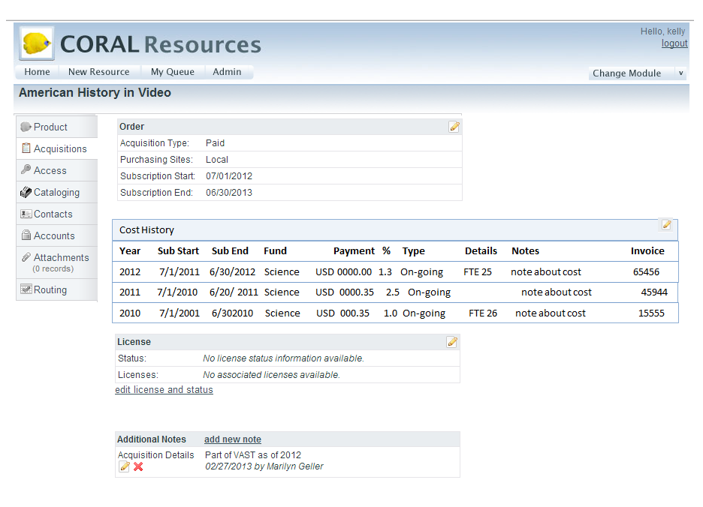

+++ lnclude all the “Order Information”.

Will include a “License” Box below “Cost History”

Will include an “Additional Notes” Box below “Cost History”

Will not contain a “Helpful Links” box on the right-hand side of the page.

Will contain a full-width Cost History table displaying the following fields:

Year:

Sub Start:

Sub End:

Fund:

Payment:

Currency:

% Inc*

Type:

Cost Details:

Note:

Invoice:

*& Inc - this field is a calculated field and does not have an associated field in the table. The amount displayed will reflect the percentage increase in the total of payment fields of the current year and the total of the payment fields in the previous year.

Data will appear in columns below the related header.

**Other Window Modifications**

**“Add New Resource” Window**

* Change “Initial Cost” to “Cost”
* In Cost Section add year, and costNote fields

“**Edit Acquisitions Information**” Window

* Add Resource Name to header

Order Section - Change the following label text:

* “Subscription Start” to “Sub Start”
* “Subscription End” to “Current Sub End”

Remove “Initial Cost” Section

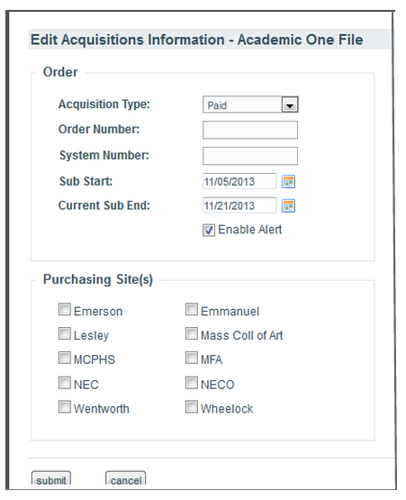

**“Edit Cost Information”** Window - this is an entirely new Window

Without Enhanced Cost History

* Include Resource Name in header

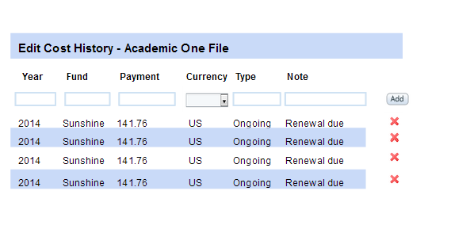

Cost Section - Column headers as follows:

* Year:
* Fund:
* Payment:
* Currency:
* Type:
* Note:

Add input boxes for the following fields:

* year
* fund
* payment
* currency
* costType
* costNote

- followed by the “Add” button

With Enhanced Cost History enabled

* Include Resource Name in header

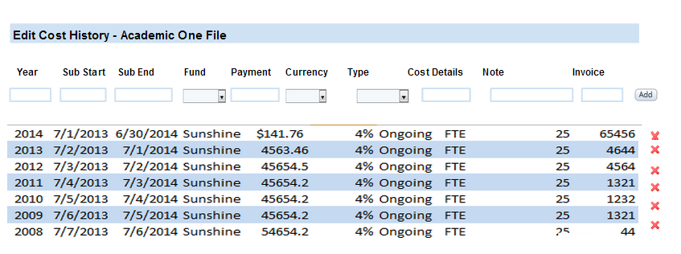

Cost Section - Column headers as follows:

* Year:
* Sub Start:
* Sub End:
* Fund:
* Payment:
* Currency:
* Type:
* Cost Details:
* Note:
* Invoice:

Add input boxes for the above fields:

* year
* subscriptionStart
* subscriptionEnd
* fundName
* paymentAmount
* currencyCode
* orderTypeID
* costDetailsID
* costNote
* invoiceNum

- followed by the “Add” button

Previously entered data would appear below the add line with a delete option to the right of each line.

Lines would have alternating blue and white color backgrounds.

**Privileges**

Users with “Admin” or “Can View/Edit” privileges will be able to add cost information and create reports.

------

**Resource and Organization Reporting**

**Modify current Usage module to include reports.**

The goal of the Cost History Reporting component is to integrate Resource and Organization Cost Reporting into the current “Usage Reports” module and enable the creation of reports in a user-friendly interface that maintains the granularity of payments, cost types and funds in a line-by-line format.

Each report will be generated as an csv file containing a header listing the report type, selection criteria, and date the report ran, and the selected data

The “Statistics and Reports” module can be activated whether or not the institution has enabled Enhanced Cost History or the Usage Statistics Module.

**Usage Module Interface label modifications**

“Usage Reports” renamed “Statistics and Reports”

html header tag text changed from “Usage Reports” to “Statistic and Reports”

**Functional modifications**

Each report will be generated as an csv file containing a header listing the report type, selection criteria, and date the report ran, and the selected data

Add the following 5 report titles in alphabetical order with the existing reports, to the “Select Report” drop down menu that appears on the main page:

* Cost Report - Cost Type
* Cost Report - Resource Cost History
* Cost Report - Organization Cost History
* Cost Report - Fund Report
* Report - Subscription End Date

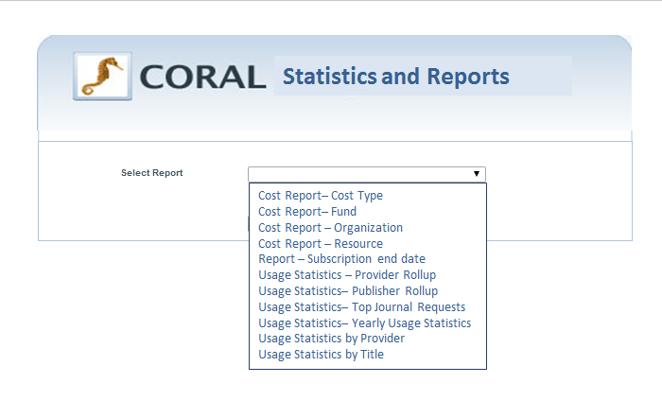

Selecting a Report type will expand the report generating screen so that the box now includes:

.

1. Report Criteria
2. Report Fields

Report Criteria Fields lists the fields that can be selected and or input for use in querying the tables. Some of the fields will be free text, while some will offer selection options. Some reports will also include a “Computed percent change interval” field into which a user can add year interval which the report will use to compare values between years.

Report Fields presents a list of selectable fields that the user can choose to include in the report.

Available fields will be determined by the report type and whether or not the institution has enabled Enhanced Cost Reporting.

**Report Criteria and Results Fields**

**Sample Screen:**

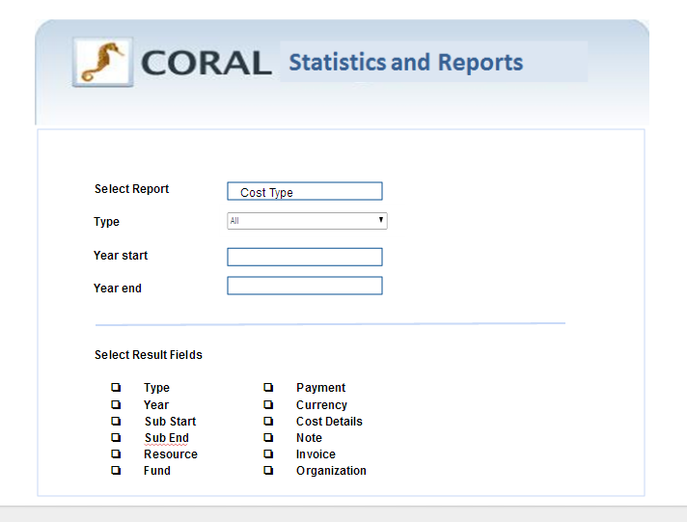

Cost Type Report

* Report Criteria Fields
  + Type
  + Year start (free text)
  + Year end (free text)
* Result Fields
  + Type
  + Year
  + Sub start
  + Sub end
  + Resource
  + Fund
  + Payment
  + Currency
  + Cost Details
  + Note
  + Invoice
  + Organization

Fund Report

* Report Criteria Fields
  + Fund (free text)
  + Year start (free text)
  + Year end (free text)
* Result Fields
  + Fund (free text)
  + Year
  + Sub start
  + Sub end
  + Cost Type
  + Year start
  + Year end
  + Organization
  + Resource
  + Payment
  + Currency
  + Cost Details
  + Note
  + Invoice
  + Organization

Organization Report

* Report Criteria Fields
  + Organization
  + Year start
  + Year end
  + percent change interval
* Result Fields
  + Organization
  + Year
  + Computed percent change interval
  + Computed total payment per year
  + Resources
  + Sub start
  + Sub end
  + Cost Types
  + Payment

Resource Report

* Report Criteria Fields
  + Resource
  + Year start
  + Year end
  + Sub start
  + Sub end
  + Computed percent change interval
  + Computed percent change interval
  + Computed percent change interval
* Result Fields
  + Resource
  + Year Sub start
  + Sub end
  + Cost Type
  + Computed percent change interval
  + Computed percent change interval
  + Computed percent change interval

**Privileges**

Users with “Admin” or “Can View/Edit” privileges will be able to add cost information and create reports.

Users with “View Only” privileges will only be allowed to see the cost history info, and be able to generate reports.