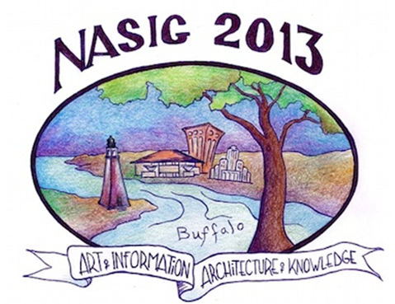

**NASIG’s 28th Annual Conference: June 6th to June 9th 2013 in Buffalo, NY**

**“The Art of Information/The Architecture of Knowledge”**

[**http://www.nasig.org/conference_registration.cfm**](http://www.nasig.org/conference_registration.cfm)

NASIG 2013 continues the organization’s tradition of offering conferences that have strong, engaging programs and numerous opportunities to discuss issues and network in a relaxed environment with colleagues—publishers, vendors, print and e-resources providers, and librarians.

* Need to learn more about e-resources, scholarly communication issues, RDA, linked data, DDA, collection management issues for both electronic and print resources, licensing, copyright, IRs, discovery services, workflows and much more? The NASIG conference is the place to be!

**Featured Speakers:**

* Bryan Alexander (National Institute for Technology in Liberal Education), “Libraries and Mobile Technologies in the Age of the Visible College”
* Megan Oakleaf (Associate Professor of Library and Information Science, Syracuse University), “The Value of Serials in Academic and Special Libraries”
* Siva Vaidhyanathan (Robertson Professor in Media Studies, University of Virginia), “Googlization and the Challenge of Big Data”

**Preconferences:**

* June 5, 1pm-5pm: *Library as Publisher* (Timothy S. Deliyannides, University of Pittsburgh)
* June 5, 1pm-5pm and June 6, 8am-noon (2 parts): *RDA & Serials: Transitioning to RDA within a MARC 21 Framework* (Valerie Bross (UCLA), Les Hawkins and Hien Nguyen (Library of Congress))
* June 6, 8am-noon: *Copyright in Practice: A Participatory Workshop* (Kevin Smith, Duke University)

There will be networking opportunities, a Vendor Expo and fun optional events. For a full list of conference activities and information on Buffalo, see the conference website at:

[**http://www.nasig.org/conference_registration.cfm**](http://www.nasig.org/conference_registration.cfm)

Got questions? [**conf-plan@nasig.org**](mailto:conf-plan@nasig.org)

**SEE YOU IN BUFFALO!**