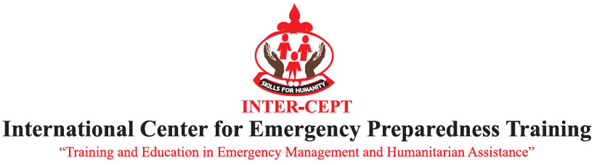
TRAINING IN INTERNATIONAL HUMANITARIAN RESPONSE AND MANAGEMENT.

APPLICATION FORM

Personal Details:
Title – Dr/Mrs/Mr/Miss/Other: MR | Surname/Family Name: ABEDI
First Name:VINCENT | Middle Name:MARK
Previous Last Name (if applicable): | Male/Female: MALE
Country of Birth: GHANA | Date of Birth: 20-04-1966
Nationality:GHANAIAN | Passport Number: NOW ACQUIRING ONE
Have you continued to live in your country of birth up to the present day, with no gaps in residence? Yes/No YES
What country have you been living in for the past three years? GHANA

Permanent Address:  P.O.BOX 455,NSAWAM-EASTERN REGION,GHANA  Telephone No.233 208242191 | Address for Correspondence (if different)  Telephone No.
Mobile No: 233 208242191 | Email address:abedi_m.vincent@yahoo.com

Programme Application Details:
Programme Title: Advanced Diploma in Emergency and Disaster Management
Proposed Start Date:
If the programme includes a choice of modules / options, please indicate your preference(s) here:

Academic Qualifications: (please attach/scanned copies of certificates)
University/Institution Attended:

Degree Title: SOCIAL STUDIES | Qualification Gained: DIPLOMA
Dates of Attendance: 2008 | Year of Award: 2010
Subject(s) ADULT EDUCATION,MANAGEMENT,PSYCHOLOGY,GENDER,ENVIROMENTAL,LITRACY

DISTANCE LEARNING,

Professional Qualifications: (please attach scanned copies of certificates)
Please give details of any additional professional or other qualifications
WATER,ENVIRONMENTAL SANITATION PRACTITIONER OR SOCIAL WORKER

Employment History: (if applicable)
Position Held | Dates | Employer & Country | Brief Description of Responsibilities
DIRECTOR | 2011 | VIMAS WASH ENTERPRISE | WATER,ENVIRONMENTAL SANITATION ENTERPRISE,ADVOCATE,EDUCATOR,TOT
DIRECTOR | 2000-2010 | AMPA RESOURCE FOUNDATION | INCHARGE OF WATER,ENVIRONMENTAL SANITATION ISSUESS OF THE NGO
SECURITY GUARD | 2004-2012 | GHANA COCOA BOARD | INCHARGE OF CENTRAL STORES OF THE COMPANY
MEMBER | 2006-2012 | MUNICIPAL LEAP IMPLEMENTATION TEAM MEMBER | INCHARGE OF MOBILIZATION AND EDUCATION

Future plans (what do you intend to do after completing this programme?):
TO ACQUIRE MORE KNOWLEDGE ON INTERNATIONAL HUMANTERIAN RESPONSE AND MANAGEMENT MEMBER IN GHANA TO BE ABLE TO ADDRESS ANY EMERGENCY CRISES IN GHANA AND IN THE WORLD

Health: Details of any health issues, disabilities or support needs
NO, AND NOT YET KNOWN

Criminal Convictions:

Do you have any criminal convictions?
(If you do not answer this question we cannot process your application)

Yes No

*

If you have answered yes, please give details of the conviction in terms of sentence served or caution received.

*Referees: (separate form attached)
Name PROF.DR.E.K.BOON  Position LECTURER  Address 38 ADJIRIGANO STREET, EAST LEGON, P.O.BOX KA 16461  AIRPORT – ACCRA, GHANA  Email eboon@vub.ac.be/ Iced @ghana.com  Telephone No. MOBILE +233-243-229405 | Name MR. ALBERT WIREDU  Position QUALITY ASSURANCE MANAGER  Address PIONEER FOOD CANNERY, P.O BOX 40,TEMA  Email albert.wiredu@mnbrands.com  Telephone No. 0244-836566
* Note concerning referees: Referees should be Senior Academic and/or Professional persons who are currently responsible, or have recently been responsible, for supervising you. Close personal friends and family are not acceptable as referees.

A referee should be your current supervisor or a recent employer.

Personal Statement: (Please give details of why you applied for the programme and what you expect to gain from attending the programme)
TO BECOME AN INTERNATIONAL EMERGENGY HUMANTERIAN
RESPONSE TEAM MEMBER IN THE FIELD OF DISASTER RISK REDUCTION & WATER AND A TEAM PLAYER TO HELP RURAL COMMUNITIES
TO SOLVE PROBLEMS LOCAL, NATIONAL AND GLOBALLY

.

Financial Support/Sponsorship
Candidates must provide evidence that they will have sufficient funds available for their fees and maintenance during the programme. If sponsored please state the name of authority responsible for payment of tuition fees.

1. Self-funded: Yes / No. WILL BE LOOKING FOR SPONSORSHIP

2. Sponsored: Yes / No. WILL BE LOOKING FOR SPONSORSHIP

Have you applied for a scholarship / sponsorship: Yes / No
If ‘yes’, please state name and address of funding body:

Have you received a scholarship / sponsorship offer: Yes / No NO
If ‘Yes’, please enclose a copy of your offer letter.
If ‘No’, please state the date by which you expect to have received an offer:
Please ensure that you notify the Programme Administrator and forward a copy of your offer letter as soon as it becomes available.

Application forms may be e-mailed to the appropriate programme administrator:

The Programme Administrator (Title of programme)
Registry Office, International Centre for Emergency preparedness, (INTER-CEPT)
P.O. Box Nairobi -Kenya
E-mail: registrar@inter-cept.org

Check-list

Evidence of academic or professional qualifications
(including transcripts where necessary) Email copies

Copies of English Language certificates (where appropriate)

Evidence of funding

Passport photographs x 2 (with name on reverse) Scanned copies will be accepted.

Other relevant items (please specify)

